CURL
# Source: Chatgpt (GPT-4-turbo) at [6/24/2025]
cURL (short for Client for URLs) is a command-line tool and library (libcurl) used to send data to or fetch data from a server using various protocols, most commonly HTTP and HTTPS.
It's widely used for testing REST APIs, automating web requests, downloading files, and scripting API calls in development, DevOps, and backend systems.

🧰 Key Features of cURL
# Source: Chatgpt (GPT-4-turbo) at [6/24/2025]
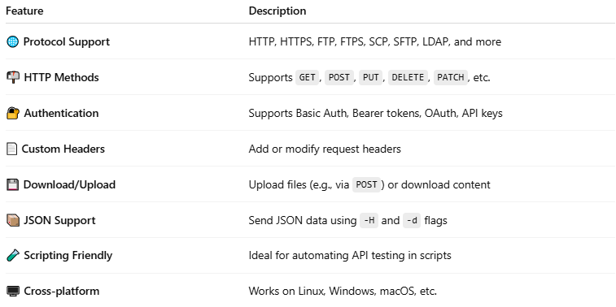
Feature | Description
🌐 Protocol Support | HTTP, HTTPS, FTP, FTPS, SCP, SFTP, LDAP, and more
📬 HTTP Methods | Supports GET, POST, PUT, DELETE, PATCH, etc.
🔐 Authentication | Supports Basic Auth, Bearer tokens, OAuth, API keys
📄 Custom Headers | Add or modify request headers
💾 Download/Upload | Upload files (e.g., via POST) or download content
📦 JSON Support | Send JSON data using -H and -d flags
🧪 Scripting Friendly | Ideal for automating API testing in scripts
🖥️ Cross-platform | Works on Linux, Windows, macOS, etc.

📌 Basic Syntax
# Source: Chatgpt (GPT-4-turbo) at [6/24/2025]
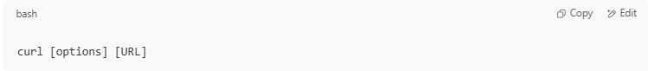
curl [options] [URL]

🚀 Common cURL Examples

1. GET Request
# Source: Chatgpt (GPT-4-turbo) at [6/24/2025]
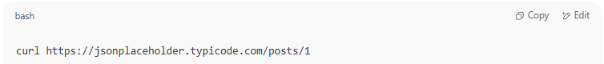
curl https://jsonplaceholder.typicode.com/posts/1

2. POST Request with JSON
# Source: Chatgpt (GPT-4-turbo) at [6/24/2025]
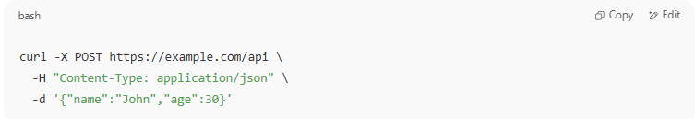
curl -X POST https://example.com/api \
-H "Content-Type: application/json" \
-d '{"name":"John","age":30}'

3. Add Authorization Header
# Source: Chatgpt (GPT-4-turbo) at [6/24/2025]
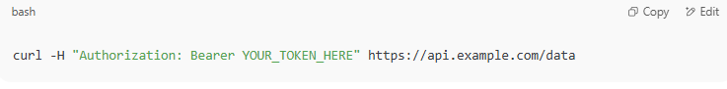
curl -H "Authorization: Bearer YOUR_TOKEN_HERE" https://api.example.com/data

4. Save Response to a File
# Source: Chatgpt (GPT-4-turbo) at [6/24/2025]
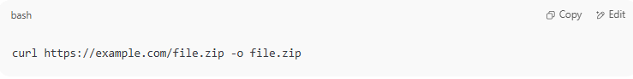
curl https://example.com/file.zip -o file.zip

5. Send Form Data (application/x-www-form-urlencoded)
# Source: Chatgpt (GPT-4-turbo) at [6/24/2025]
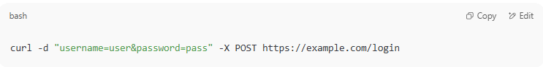
curl -d "username=user&password=pass" -X POST https://example.com/login

🆚 cURL vs GUI Tools (e.g., Postman, Insomnia)
# Source: Chatgpt (GPT-4-turbo) at [6/24/2025]
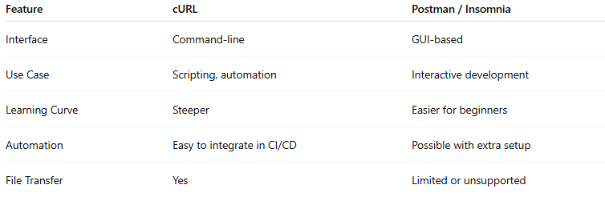

Feature | cURL | Postman / Insomnia
Interface | Command-line | GUI-based
Use Case | Scripting, automation | Interactive development
Learning Curve | Steeper | Easier for beginners
Automation | Easy to integrate in CI/CD | Possible with extra setup
File Transfer | Yes | Limited or unsupported

🧪 Use Cases
# Source: Chatgpt (GPT-4-turbo) at [6/24/2025]
- Quick API testing in terminal
- Scripting API calls in bash/Python scripts
- CI/CD pipelines for health checks
- Downloading/uploading files over HTTP/SFTP

Download CURL
# Source: Windows ScreenShots at [6/24/2025]
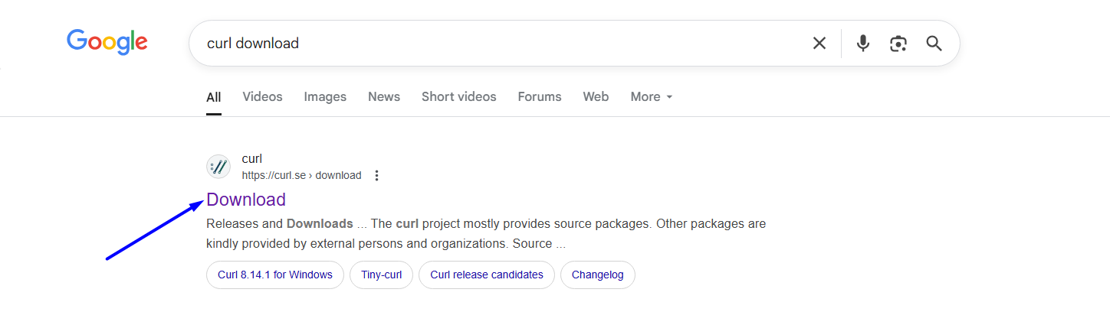
https://curl.se/download.html
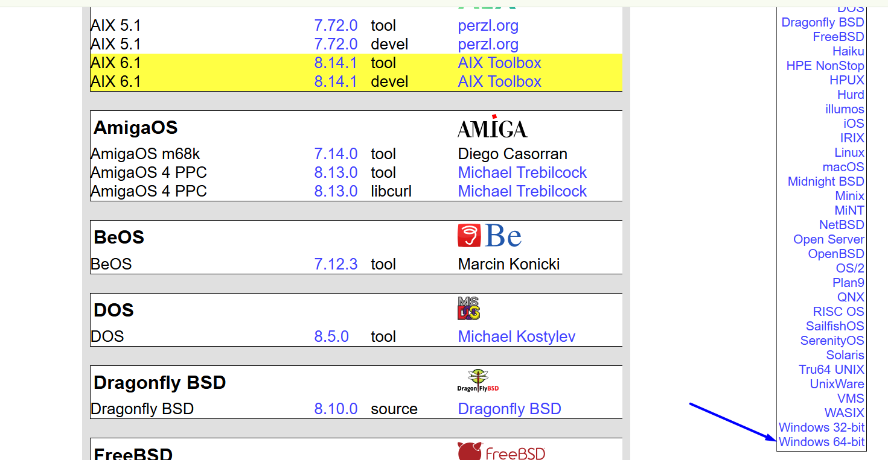
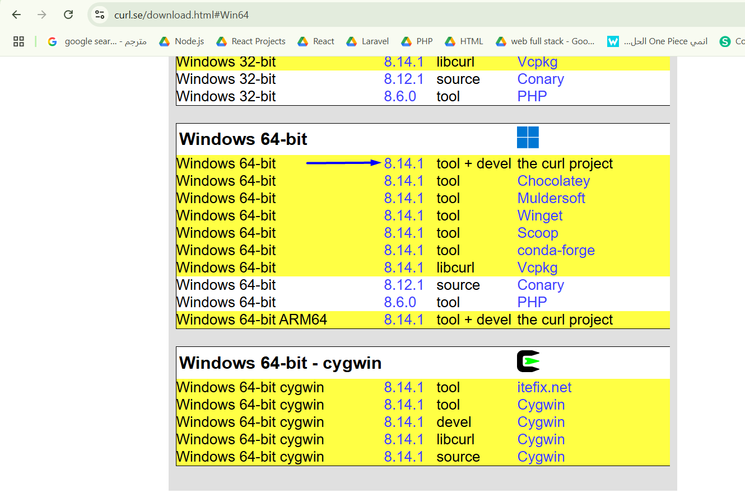
https://curl.se/windows/
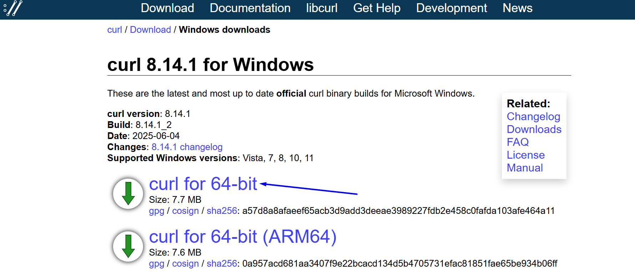

Install CURL
# Source: Windows ScreenShots at [6/24/2025]
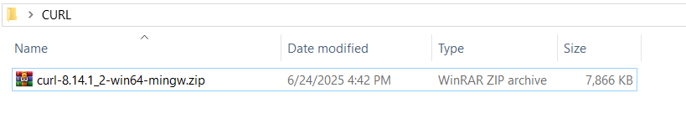
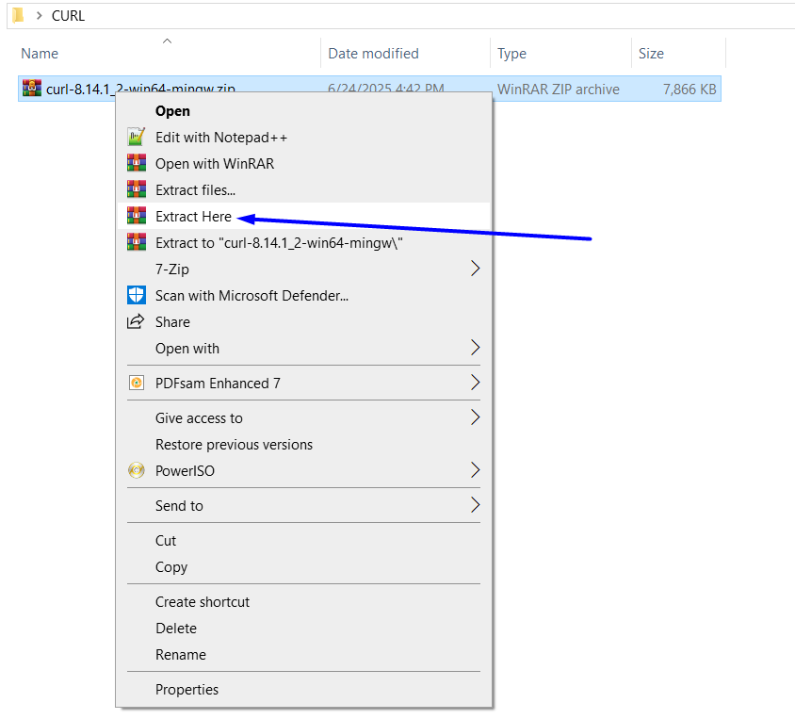
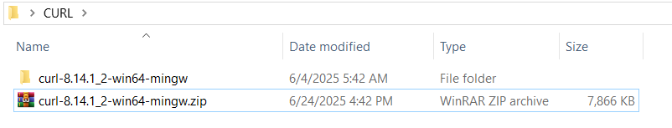

Run CURL
# Source: Windows ScreenShots at [6/24/2025]
C:\Users\tom\Desktop\CURL\curl-8.14.1_2-win64-mingw\bin
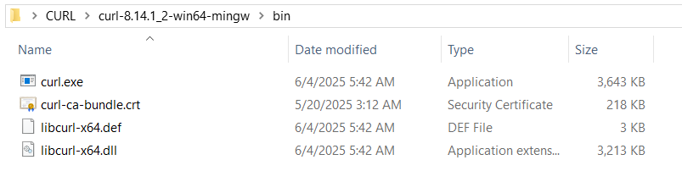
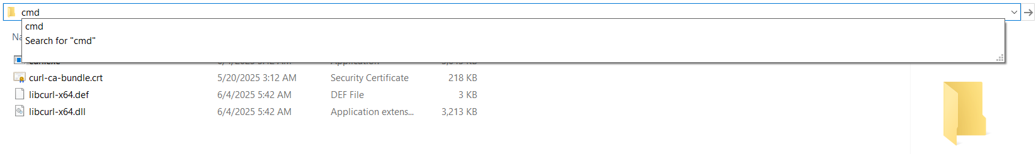
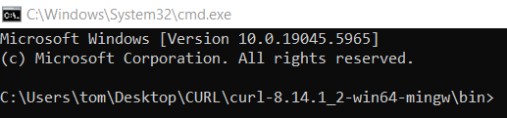
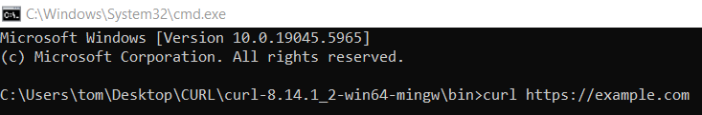
curl https://example.com
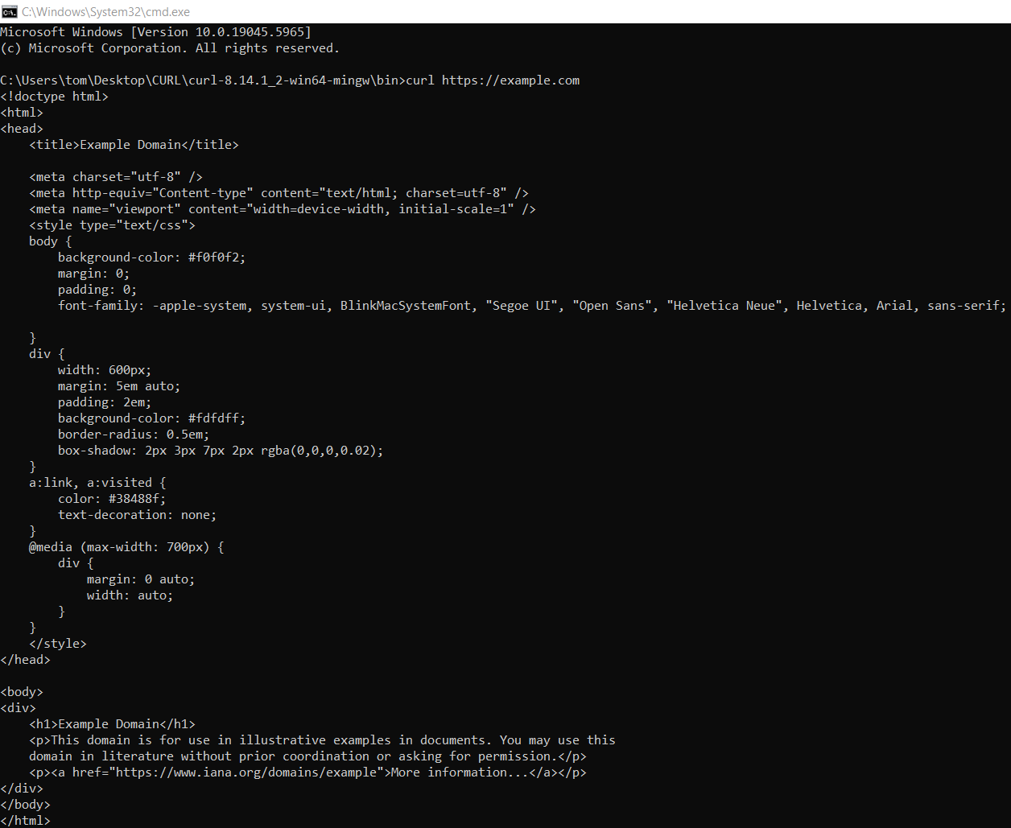

Add it to your System PATH
# Source: Windows ScreenShots at [6/24/2025]
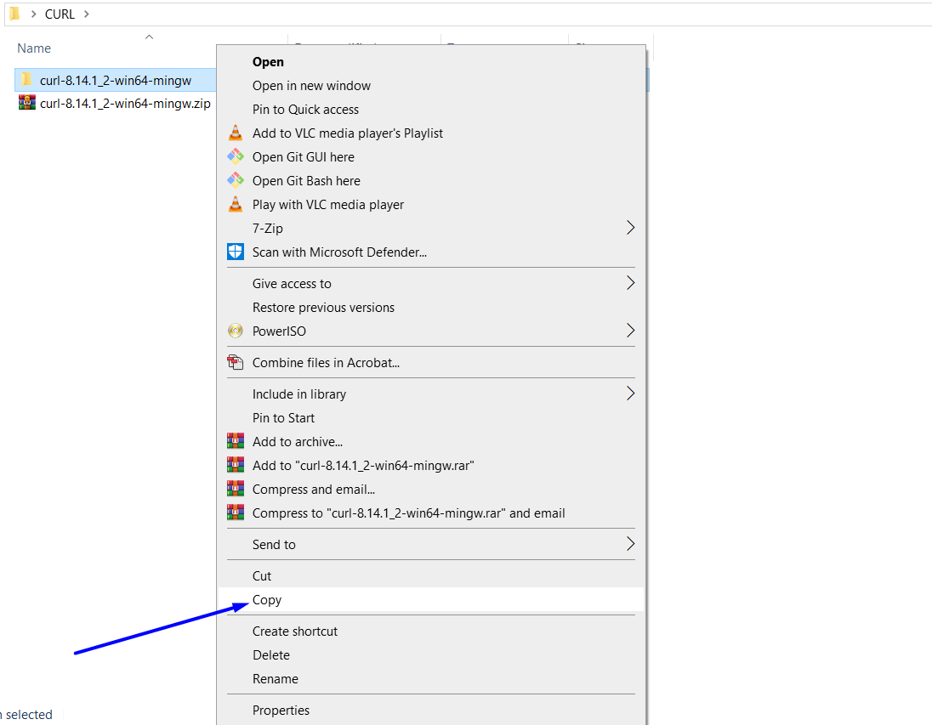
C:\tools
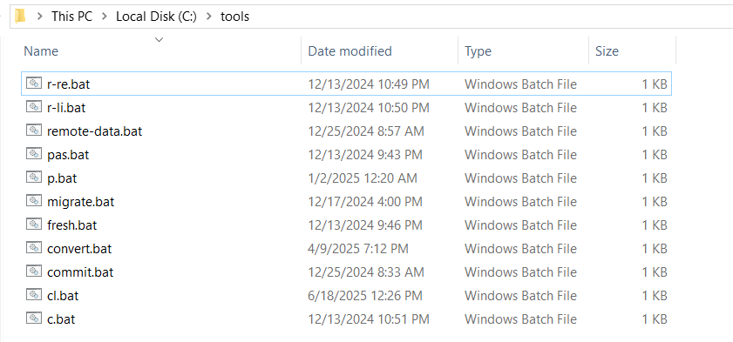
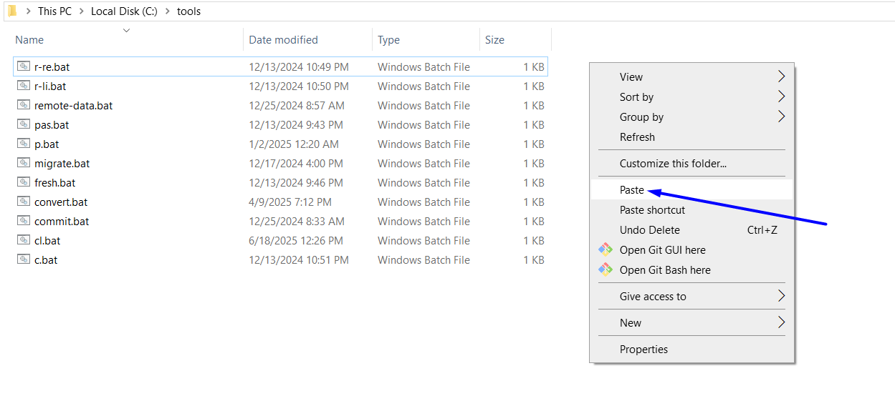
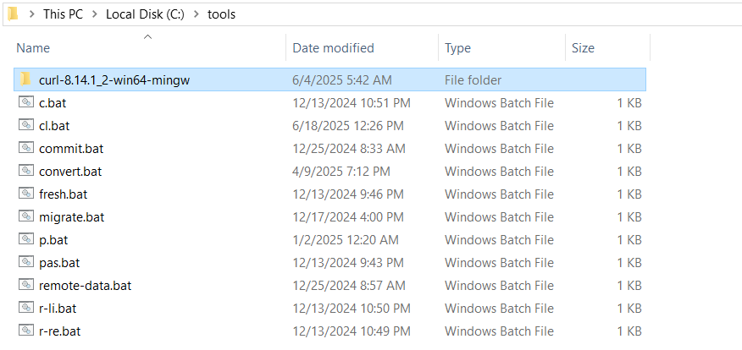

COPY THIS path
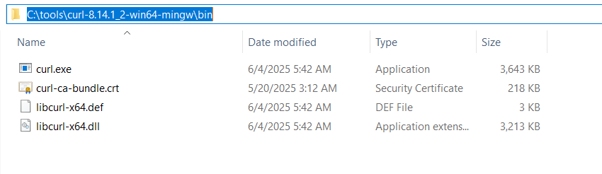
C:\tools\curl-8.14.1_2-win64-mingw\bin
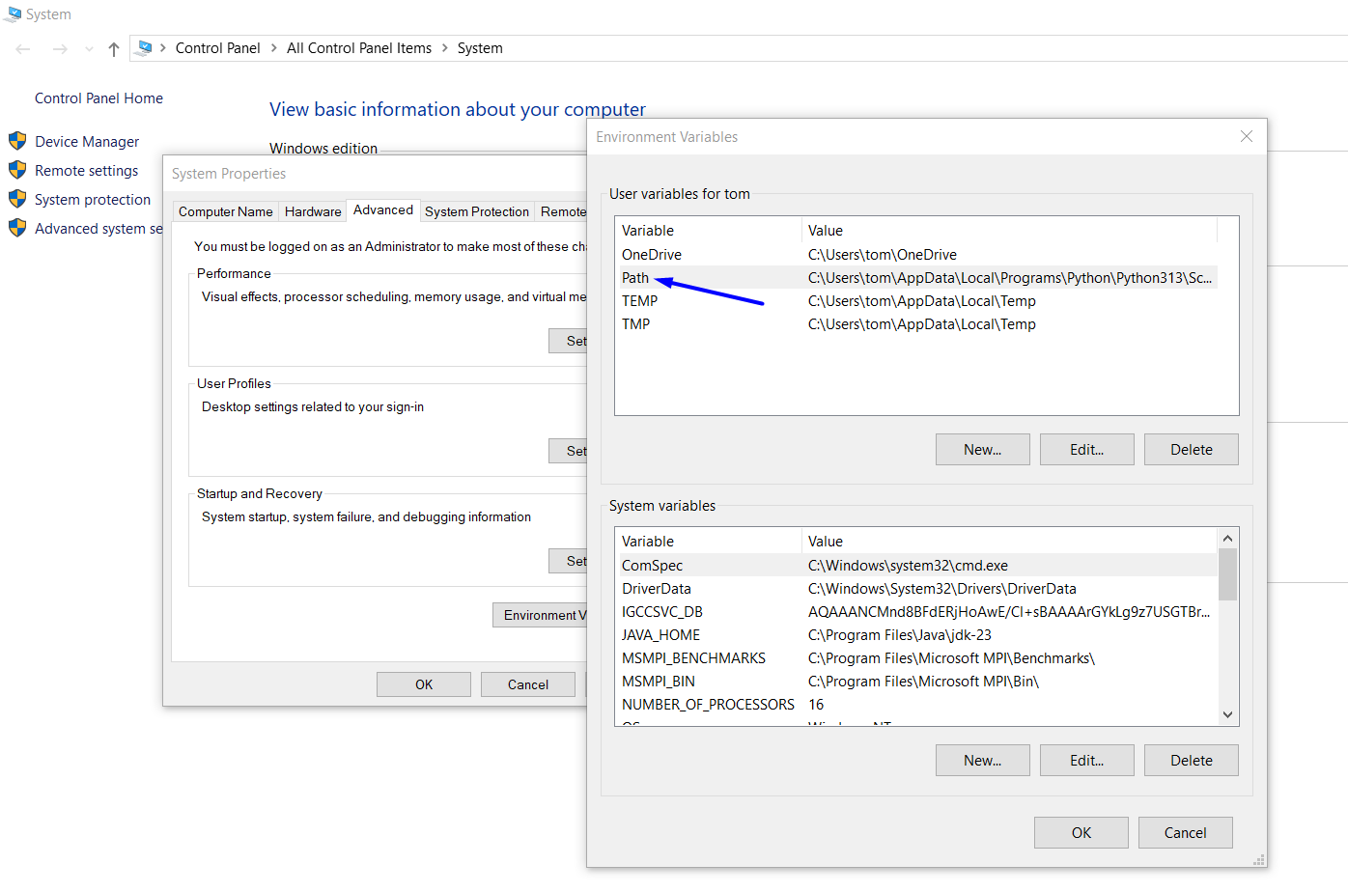
Paste path here
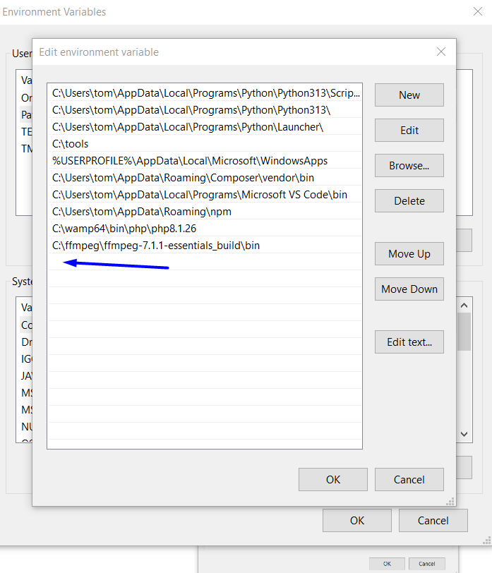
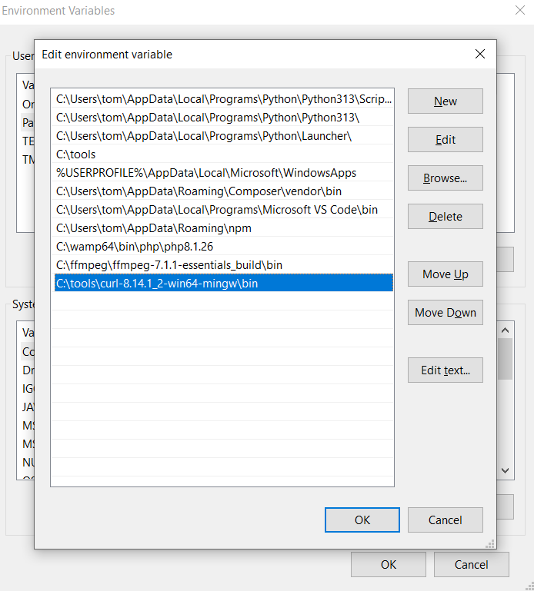
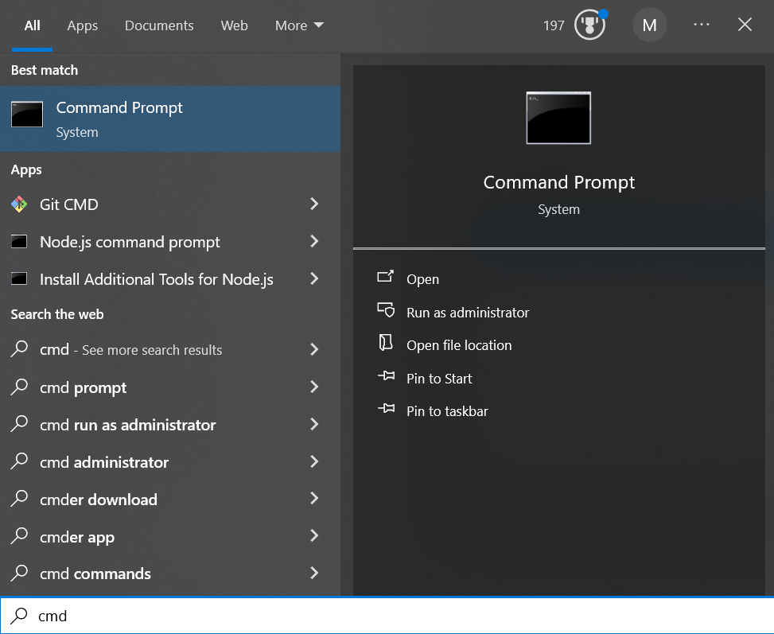
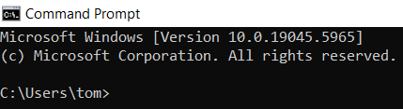
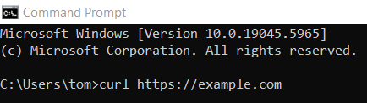
curl https://example.com
